SECTION-2 - (CSS assignments)

1. Create a new branch ‘css-assignments’.

Description: C:\Users\MM0001\Downloads\cs3.PNG

1. Switch to ‘css-assignments’ branch.

Description: C:\Users\MM0001\Downloads\cs4.PNG

1. Copy all CSS assignments inside ‘Assignments’ folder.
2. Commit CSS assignments into ‘css-assignments’ branch.

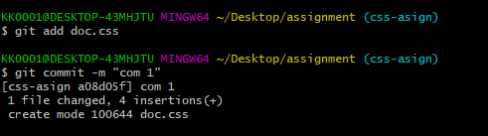

1. Make minor changes into README.txt file on line 1 belonging to ‘css-assignments’ branch.
2. Commit those changed files.

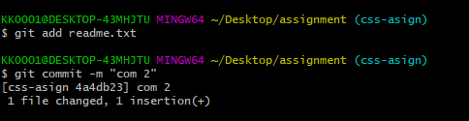

1. Switch to master branch.
2. Make minor changes into README.txt file on line 3 & commit those changes into master.

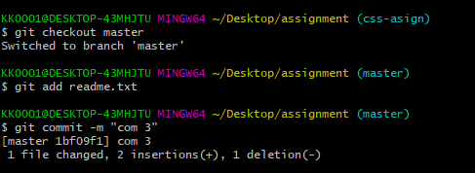

1. Again switch to ‘css-assignments’ branch.
2. Make minor changes into few files belonging to ‘css-assignments’ branch.
3. Commit those changes.

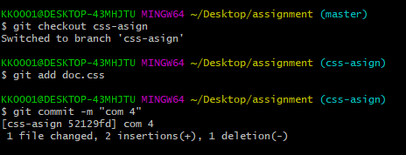

1. Switch to master.

Description: C:\Users\MM0001\Downloads\cs9.PNG

1. Merge ‘css-assignments’ branch into master. Confirm all css assignments are shown in master.

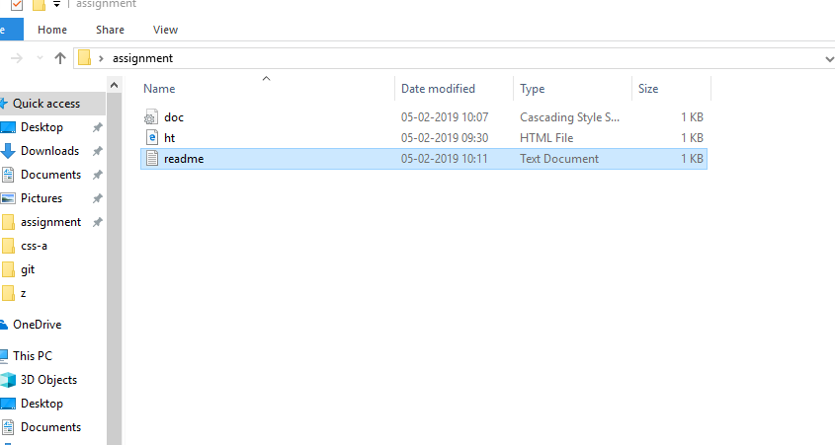

1. Finally delete the ‘css-assignments’ branch.

